**Section 1: Creating a New Enterprise Geodatabase**

This section describes how to create a new enterprise geodatabase. ArcGIS has a tool that creates the database. When you run the tool, a database will be created on a server that goes by the name of “beryl”. PostgreSQL is the database platform. PostgreSQL is an open-source database-management software, similar to Microsoft SQLServer. In the “Database (optional)” field below, enter the name of the geologic map for which you are creating a database (i.e., “azgs_Cibola”).

1. 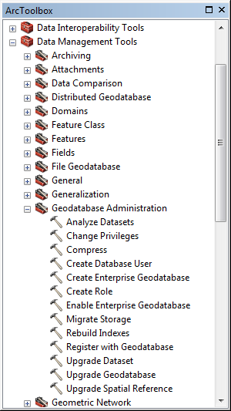Open ArcMap C:\Program Files (x86)\ArcGIS\Desktop10.2\bin\Icons\ArcMap16.png or ArcCatalog C:\Program Files (x86)\ArcGIS\Desktop10.2\bin\Icons\ArcCatalog16.png
2. Open ArcToolbox C:\Program Files (x86)\ArcGIS\Desktop10.2\bin\Icons\GeoprocessingArcToolboxWindowShow16.png
3. Run geoprocessing tool C:\Program Files (x86)\ArcGIS\Desktop10.2\bin\Icons\GeoprocessingTool16.png **Create Enterprise Geodatabase**
4. Fill out the C:\Program Files (x86)\ArcGIS\Desktop10.2\bin\Icons\GeoprocessingTool16.png Create Enterprise Geodatabase form:

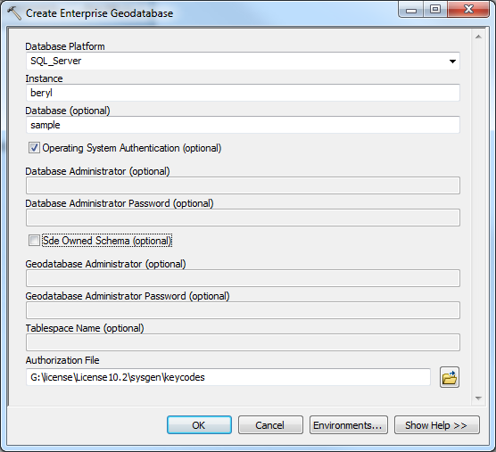

1. Click **OK** and wait.
2. Wait time is ~ 1 min 45 seconds.

**Section 2: Connect to New Enterprise Database**

1. Open ArcMap C:\Program Files (x86)\ArcGIS\Desktop10.2\bin\Icons\ArcMap16.png or ArcCatalog C:\Program Files (x86)\ArcGIS\Desktop10.2\bin\Icons\ArcCatalog16.png
2. Under Catalog Tree, expand Database Connections:

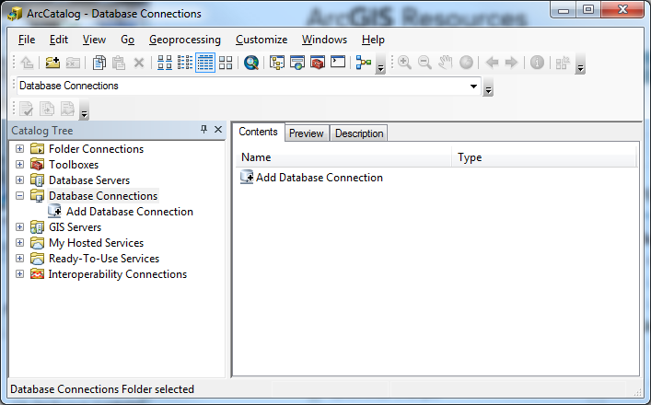

1. Double-click on **Add Database Connection**
2. Fill out Database Connection form:

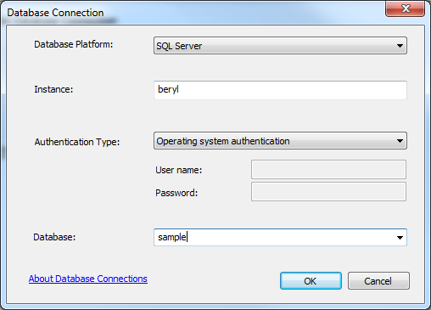

1. Click OK
2. Rename connection (the .sde file is a “connection file” that includes the path and name of the database – this .sde file will allow you to access that database).

**Section 3: Making the New Enterprise Geodatabase a Geologic Map Database (an alternative procedure is on the next page).**

This section describes how to make your new enterprise database a geologic map database.

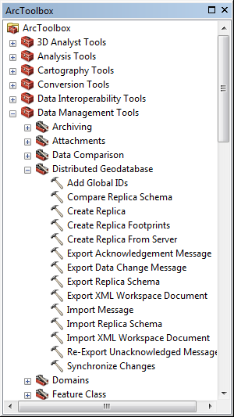

1. Open ArcMap C:\Program Files (x86)\ArcGIS\Desktop10.2\bin\Icons\ArcMap16.png or ArcCatalog C:\Program Files (x86)\ArcGIS\Desktop10.2\bin\Icons\ArcCatalog16.png
2. Open ArcToolbox C:\Program Files (x86)\ArcGIS\Desktop10.2\bin\Icons\GeoprocessingArcToolboxWindowShow16.png
3. Run C:\Program Files (x86)\ArcGIS\Desktop10.2\bin\Icons\GeoprocessingTool16.png Import XML Workspace Document
4. Fill out the C:\Program Files (x86)\ArcGIS\Desktop10.2\bin\Icons\GeoprocessingTool16.png Import XML Workspace Document form

(in ArcCatalog, drag .sde connection file into “Target

Geodatabase” box):

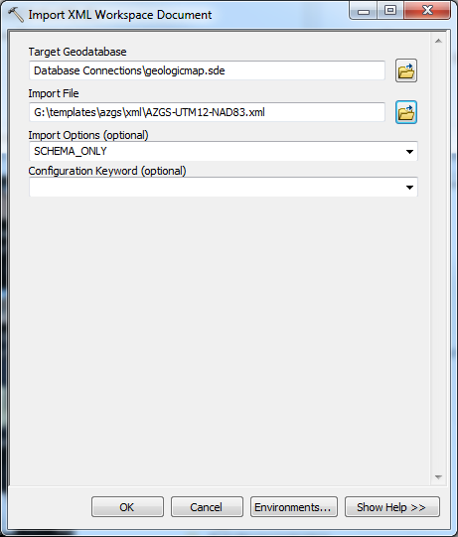

1. Click **OK** and wait.
2. Wait time is ~ 1 min 17 seconds.

**Section 3 Alternate: Making the New Enterprise Geodatabase a Geologic Map Database**

1. Open ArcMap C:\Program Files (x86)\ArcGIS\Desktop10.2\bin\Icons\ArcMap16.png or ArcCatalog C:\Program Files (x86)\ArcGIS\Desktop10.2\bin\Icons\ArcCatalog16.png
2. Right-click on database, select:
   1. Import ->XML Workspace Document…

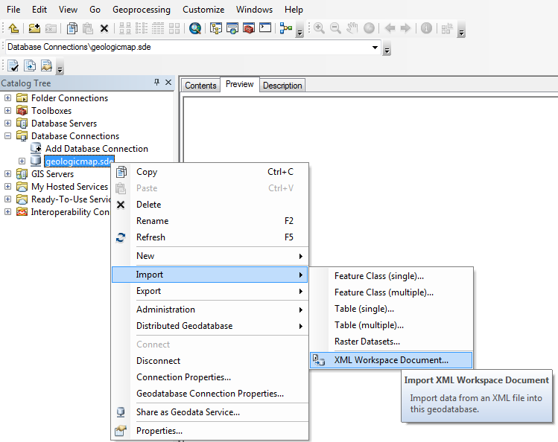

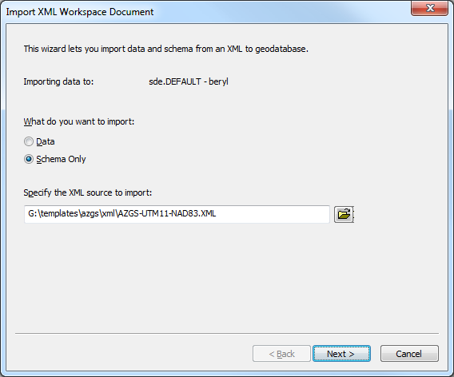

* 1. Select the xml document that has the appropriate spatial reference for the area you are working in.

**Section 4: Versioning Database**

1. 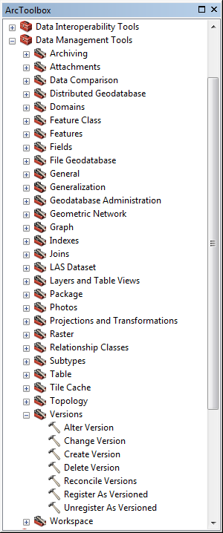Open ArcMap C:\Program Files (x86)\ArcGIS\Desktop10.2\bin\Icons\ArcMap16.png or ArcCatalog C:\Program Files (x86)\ArcGIS\Desktop10.2\bin\Icons\ArcCatalog16.png
2. Open ArcToolbox C:\Program Files (x86)\ArcGIS\Desktop10.2\bin\Icons\GeoprocessingArcToolboxWindowShow16.png
3. Run C:\Program Files (x86)\ArcGIS\Desktop10.2\bin\Icons\GeoprocessingTool16.png **Register as Versioned** inbatch mode:
   1. Right-click on tool and select batch

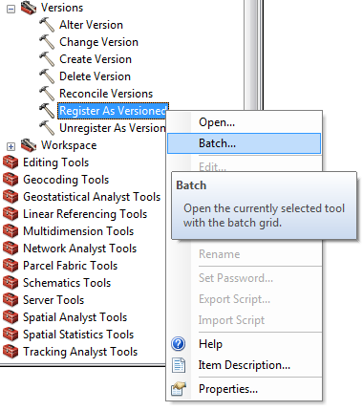

* 1. With the *exception* of the SysInfo table, drag and drop all feature datasets, feature classes and tables from database into tool window

(see window below – all feature data sets, etc.,

must be visible so they can be dragged).

* 1. Click **OK** and wait.
  2. Wait time is ~ 26 seconds.

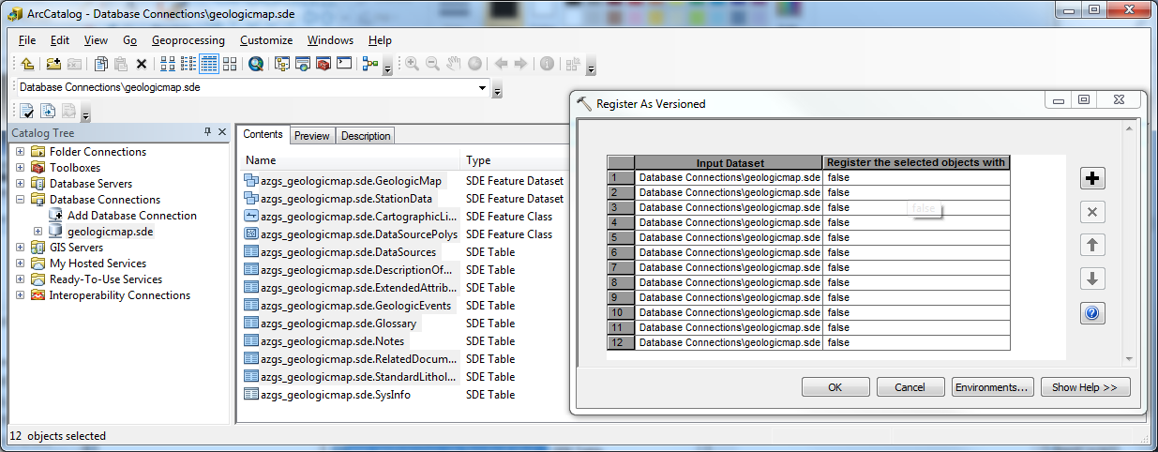

**Section 5: Creating Versions**

1. Open ArcMap C:\Program Files (x86)\ArcGIS\Desktop10.2\bin\Icons\ArcMap16.png or ArcCatalog C:\Program Files (x86)\ArcGIS\Desktop10.2\bin\Icons\ArcCatalog16.png
2. Open ArcToolbox C:\Program Files (x86)\ArcGIS\Desktop10.2\bin\Icons\GeoprocessingArcToolboxWindowShow16.png
3. Run C:\Program Files (x86)\ArcGIS\Desktop10.2\bin\Icons\GeoprocessingTool16.png **Create Version** inbatch mode:
   1. Right-click on tool and select batch

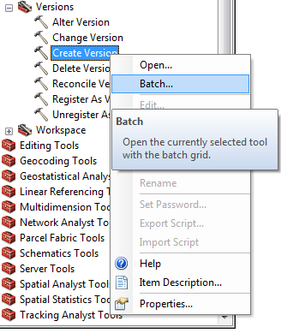

* 1. Drag database into Create Version *Input Database Connection* field
  2. Select sde.DEFAULT for *Parent Version*
  3. Input version name
  4. Select PUBLIC for *Access Permissions*
  5. 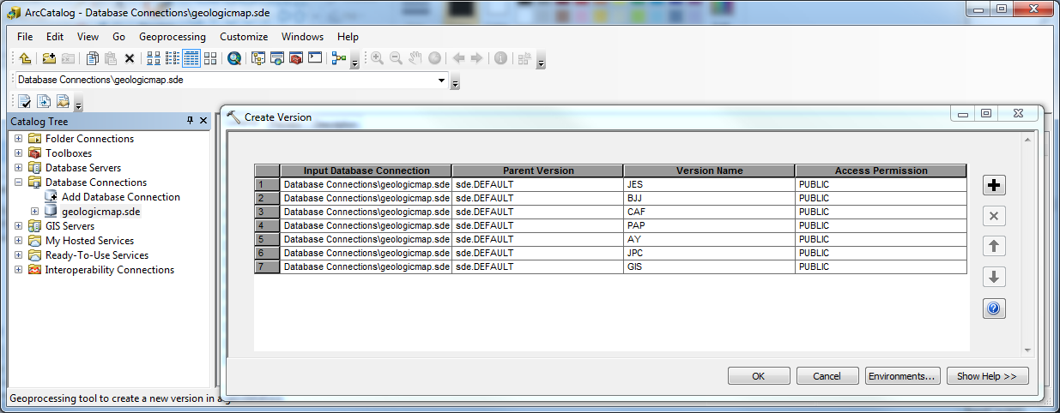Click **OK** and wait.
  6. Wait time is ~ 2 seconds.

**Section 6: Adding database version to a project.**

*Scenario 1 of 2: ArcMap project already contains data from a versioned database.*

1. Open the relevant project in ArcMap C:\Program Files (x86)\ArcGIS\Desktop10.2\bin\Icons\ArcMap16.png.

2. Select the “NCGMP Menu” button and navigate to

*Scenario 2 of 2: ArcMap project is without data.*

**Section 7: Importing Station Data**